Nitration of Methyl Benzoate
Kenny Beane, Michael Harbuck, Kristin Leger, Greta Derstine
CHEM 236—Lab Report #2
6/6/2014
Pavia Experiment #41

Abstract: 0.09 g of methyl m-nitrobenzoate was obtained by recrystallization in an electrophilic aromatic substitution reaction. The product’s identity was confirmed with melting point and IR spectroscopy. The melting point was determined to be 74° C, which is close to the literature value of 78° C. The peaks on the IR spectrum correspond with the functional groups that exist in methyl m-nitrobenzoate. The IR spectrum shows that the product contains an aromatic compound, ester, and nitro groups. The percent yield of product is 39.1%.

Introduction: Nitration of methyl benzoate to create methyl m-nitrobenzoate is an example of an electrophilic aromatic substitution reaction. In this experiment, a proton on the aromatic ring is replaced by a nitro group. (more info here)
Procedure: To begin the experiment, place a 3 mL conical vial on a scale and tare it. Add 0.21 mL of methyl benzoate to the vial to determine its weight. Then add 0.45 ml of concentrated sulfuric acid to the conical vial along with a magnetic spin vane to mix the solution. Clamp the conical vial for security, and then immerse the vial into an ice bath to begin cooling the mixture. While stirring the mixture, very slowly add a cool mixture of 0.15 mL concentrated sulfuric acid and 0.15 mL of concentrated nitric acid throughout a 15 minute period (if added too fast, the formation of byproducts rapidly increase, which reduces the yield of the final product.) After everything has been added to the conical vial, replace the ice bath with room temperature water in order to increase the temperature of the mixture to room temperature. Once the temperature of the mixture has increased to room temperature, let the mixture stand for 15 minutes without stirring. Use a Pasture Pipette to transfer the reaction mixture from the conical vial to a 50 mL beaker containing 2 grams of crushed ice. Once the ice cubes melt, collect the product using vacuum filtration with a Hirsch funnel. Allow the collected product to dry on a watch glass over night.
The next day, after the product is completely dry, weigh the crude product before performing recrystallization. Then begin recrystallization by placing an empty Craig tube and a small test tube containing methanol on a hot plate. Also place a clean metal spatula into the test tube containing the methanol to serve as a “boiling stone”, which will reduce the bubbling of methanol when it begins to boil. Transfer the dry product to the heated Craig tube, then add a minimal amount of boiling methanol to dissolve the product (drop-wise method). Remove the Craig tube from the heat and insert the Craig tube plug. Allow the Craig tube to cool slowly, and then place it in an ice bath for a few minutes to maximize crystallization. Once the mixture is chilled, transfer it from the Craig tube to a Centrifuge tube and Centrifuge the mixture. Now remove the solvent from the centrifuge tube, leaving all the crystals to be scrapped off onto a watch glass for drying using a metal spatula or a small piece of copper wire. Once the final product is dry, weigh it, calculate percent yield, determine the melting point, and obtain an IR spectrum.
Observations: When the sulfuric acid was added to the methyl benzoate, the mixture turned a golden-yellow color and the top and remained clear at the bottom. The color did not change when the sulfuric acid-nitric acid mixture was added. After letting the solution sit at room temperature for 15 minutes without stirring, the solution separated into 3 distinct layers. The top layer of the solution was a brown color, the middle layer of the solution was gray, and the bottom layer was clear. When the mixture was added to 2 grams of ice it started smoking (indicating an exothermic reaction) and white crystals immediately started to form. The crystals were further isolated by vacuum filtration
Analytic Results:
- Weight of methyl benzoate (starting material)= 0.23 grams
- Weight of crude product after initial crystallization= 0.17 grams
- Weight of final product (methyl m-nitrobenzoate) after recrystallization= 0.09 grams
- Percent yield = (0.09g/0.23g) x 100= 39.1% (I think I did this right but can someone double check?)
- Melting point = 74 °C
- IR Spectrum peaks at ~1700 cm⁻¹ (ester group), ~1200 cm⁻¹ (nitro group), and ~3030 cm⁻¹ (aromatic ring)
Discussion:
0.09 grams of methyl m-nitrobenzoate were obtained after recrystallization, giving a percent yield of 39.1%.
The theoretical melting point for methyl m-nitrobenzoate is 78° C, which is very close to the melting point of our final product, 74° C.
The IR spectrum that we obtained is consistent with the IR spectrum for methyl m-nitrobenzoate. There is a peak for the ester functional group at ~1700 cm⁻¹, for the nitro group at ~1200 cm⁻¹, and a weak peak for the aromatic ring at ~3030 cm⁻¹ (see IR spectrum below).
Based on the melting point and IR spectrum obtained in this experiment, we can conclude that we successfully synthesized methyl m-nitrobenzoate.
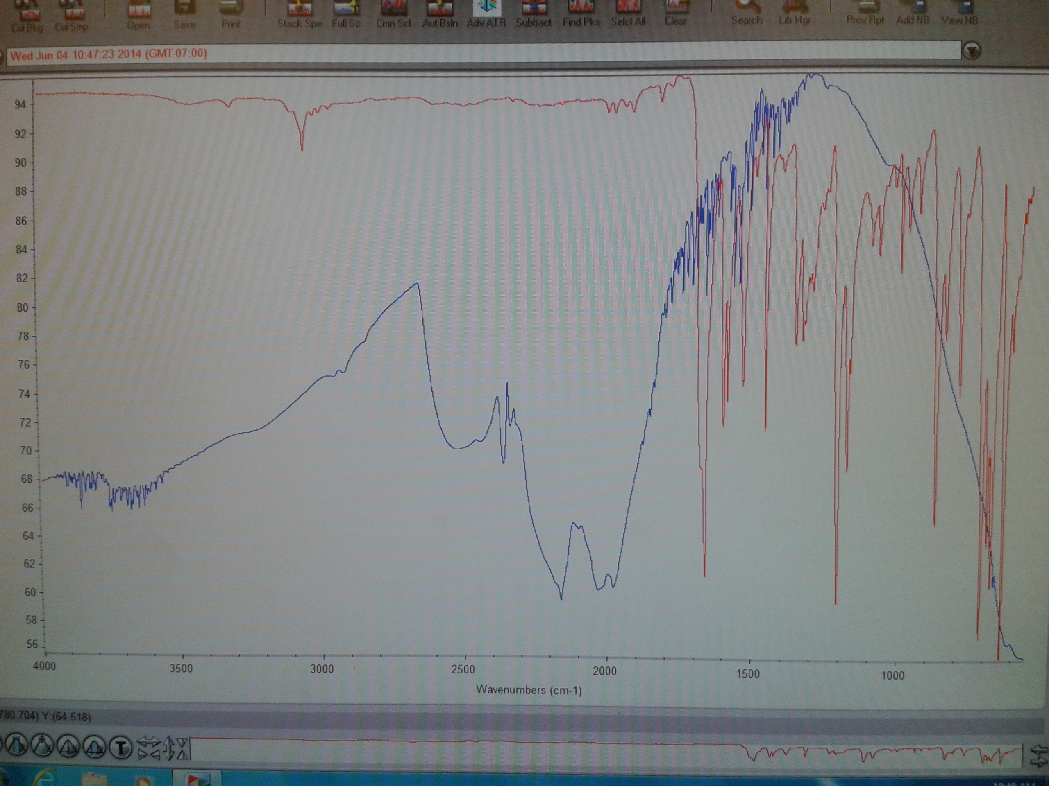
Conclusion:

